2019 Sales Performance Analysis Report

1. Introduction

This report analyses the company’s 2019 sales performance to identify key trends, evaluate monthly performance, and assess city-level contributions to revenue. It also investigates the Accountant’s claim regarding mid-year losses and evaluates the Assistant Manager’s recommendations for improving marketing focus. The analysis was conducted using SQL, which was used for data cleaning, transformation and querying of the dataset.

2. Objectives

The objectives of this analysis are to:
- Analyse monthly sales performance for 2019
- Verify the claim of revenue decline between April and July
- Analyse order volume
- Identify top-performing cities based on revenue
- Evaluate the effectiveness of the Assistant Manager’s city-focused strategy
- Provide data-driven recommendations to improve sales performance

3. Dataset Overview

The Dataset contained the following columns:
- Order ID - record of unique transactions
- Product - product sold
- Quantity - quantity of product sold
- Price each - price sold for every transaction
- Order date - date and time for each transaction
- Purchase address - store location for every transaction

4. Data cleaning and transformation

1. The original dataset contained a single column (Purchase Address) with combined information.
To improve usability, this column was split into four separate fields:
- Street
- City
- State
- Zipcode

2. A new column (month) was derived from the order date.

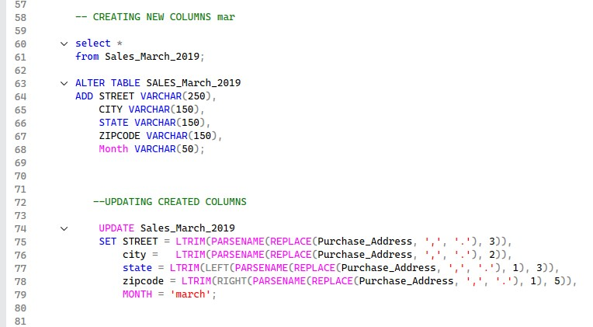
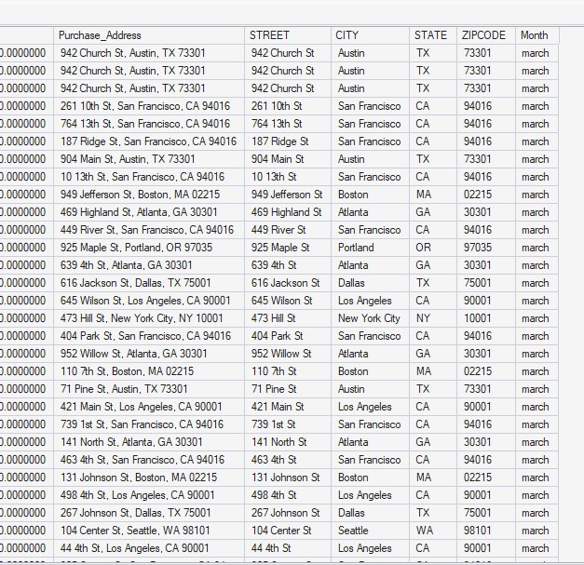

5. Key Sales Metrics Overview

From the dataset:
- Total Annual Revenue: ≈ $32.7 million
- Total Orders: ≈ 162,728 orders
- Peak Month (Revenue): December ($4.62M)
- Lowest Month (Revenue): January ($1.82M)

This indicates strong overall performance with clear seasonal variations across the year.

Monthly Sales Performance Analysis

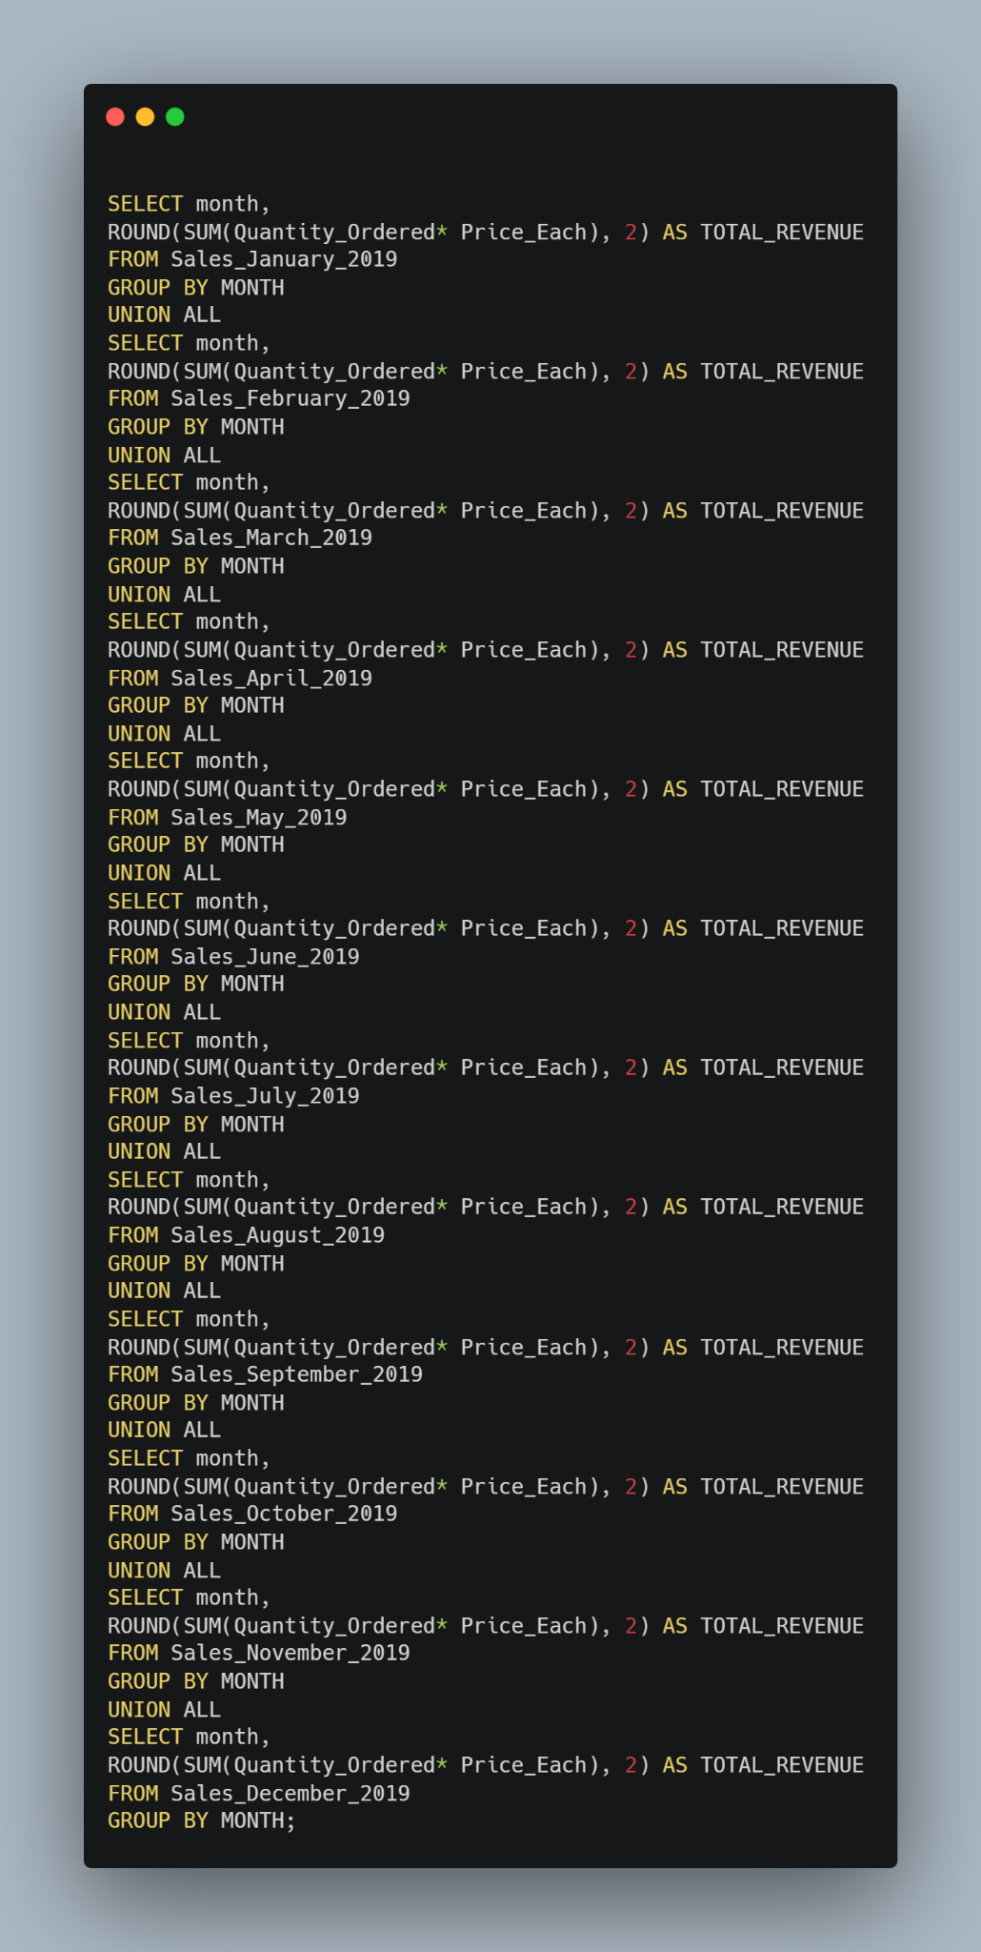

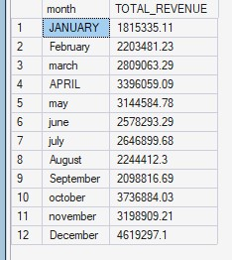

Revenue Trend (Key Figures)

- January: $1.82M
- February: $2.20M
- March: $2.81M
- April: $3.40M
- May: $3.14M
- June: $2.58M
- July: $2.65M
- August: $2.24M
- September: $2.10M
- October: $3.74M
- November: $3.20M
- December: $4.62M

Findings
- Sales increased steadily from January to April, peaking at ₦3.40M.
- From May to September, revenue declined consistently.
- A strong recovery began in October, peaking in December.

Evaluation of Accountant’s Claim

The Accountant stated that the company made losses in April, May, June, and July.

This claim is NOT fully accurate.

- April recorded strong revenue ($3.40M) — one of the highest in the month.
- The actual decline starts from May, not April.
- The weakest period is better described as May to September, not April to July.

What Happened? (Insight)

- After a strong Q1 and a peak in April, the business experienced a mid-year slump.
- The decline aligns with:
- Reduced order volume (e.g., orders dropped from 17,537 in April to ~11,000 in August/September)
- Possible seasonal demand reduction
- Sales rebounded significantly in Q4 (October–December), driven by:
- Increased order volume (December: 24,006 orders – highest)
- Likely festive/holiday demand

Order Volume Analysis
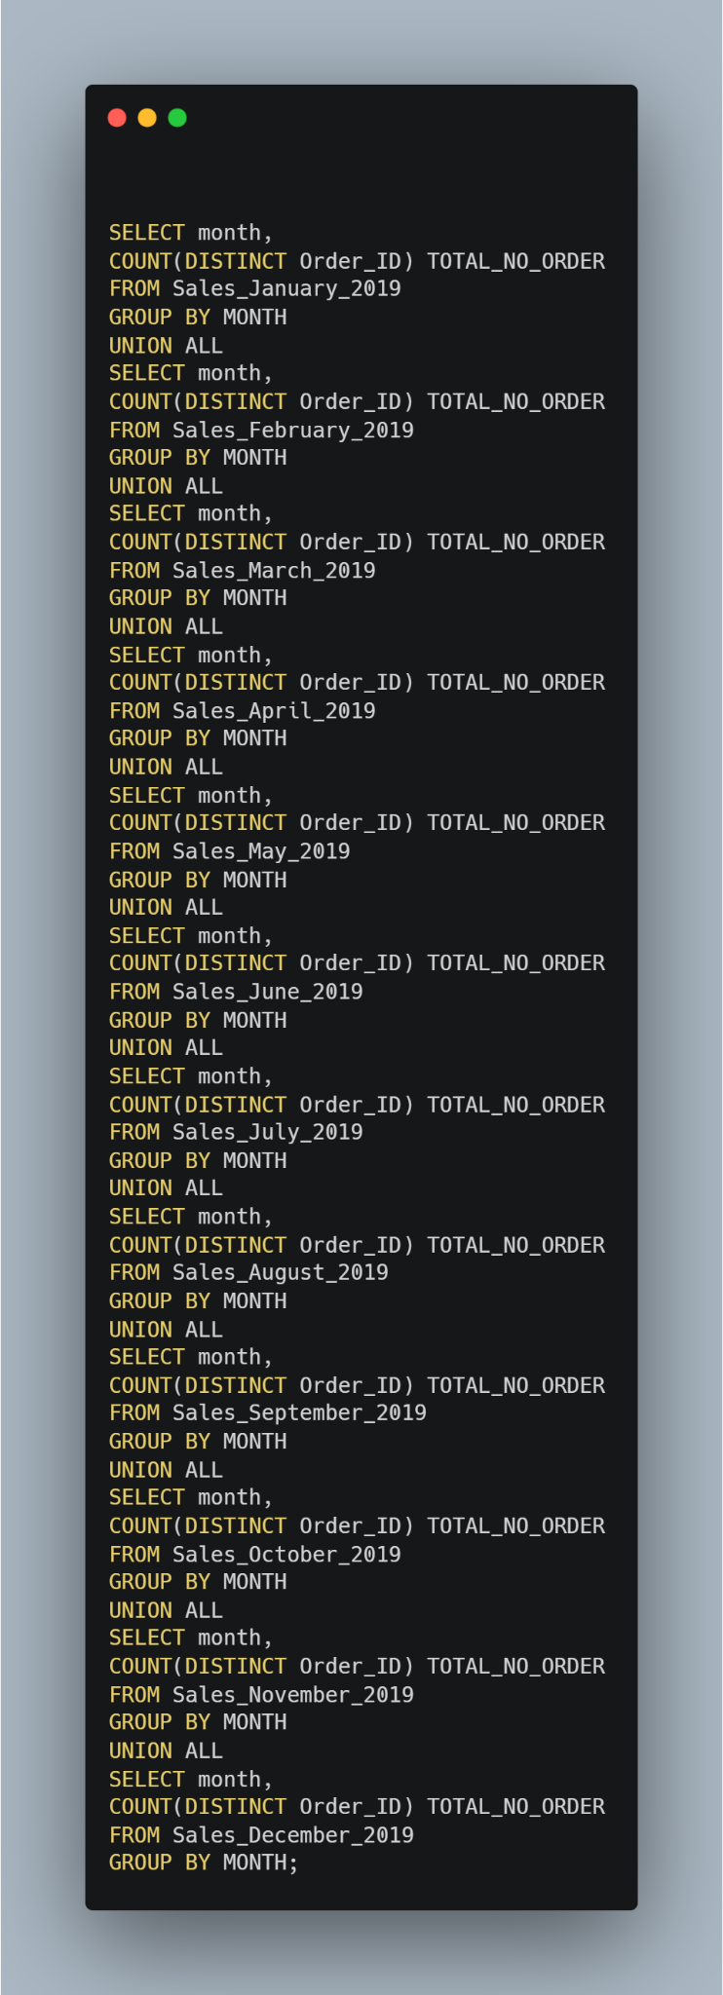
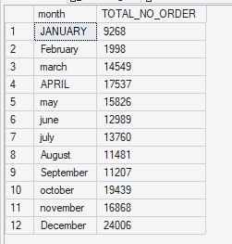

Order trends strongly support the revenue pattern:

- Highest Orders: December (24,006)
- Strong months: October (19,439), April (17,537)
- Lowest Orders: February (1,998)

Insight
- The mid-year revenue decline is directly linked to reduced customer activity, not necessarily to pricing issues.
- Growth in Q4 is driven by both higher demand and transaction volume.

City-Level Sales Performance Analysis

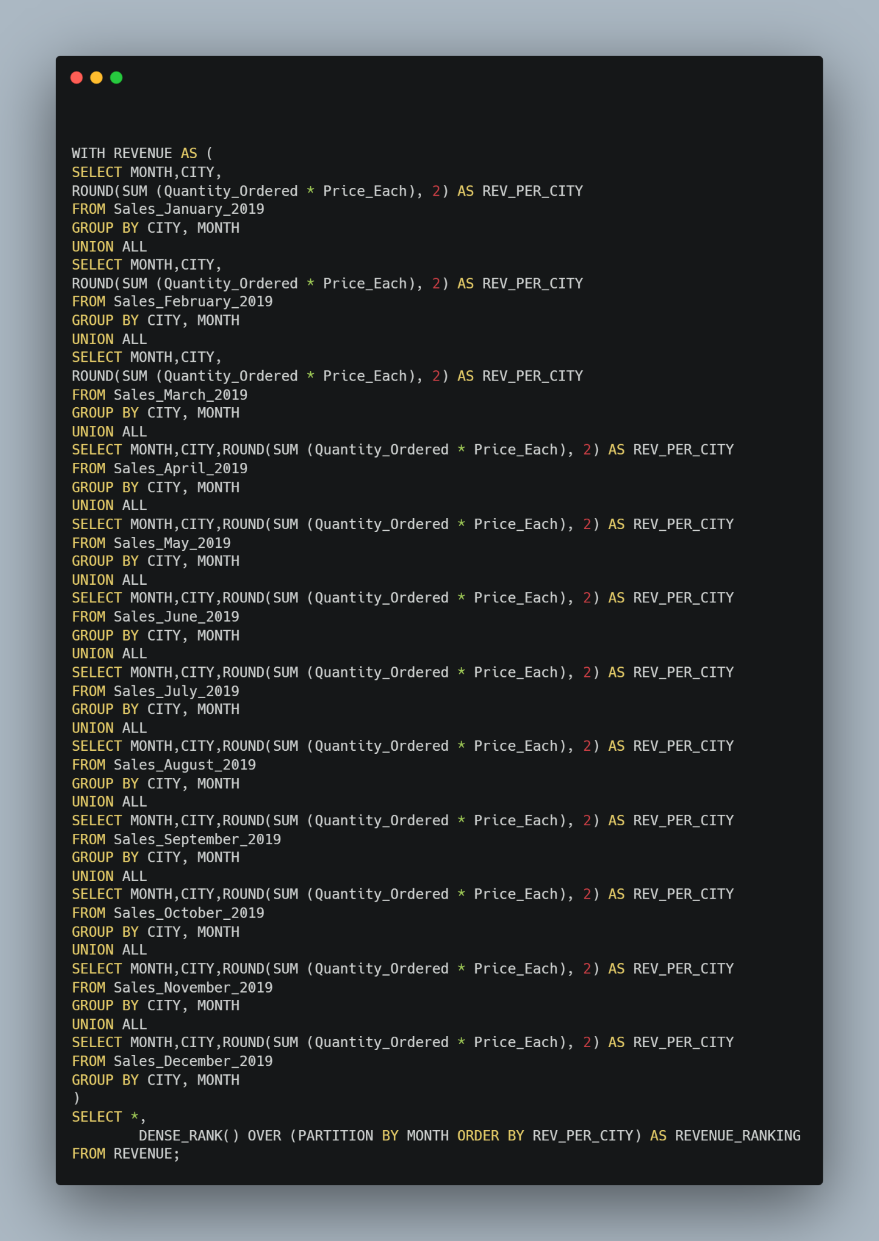
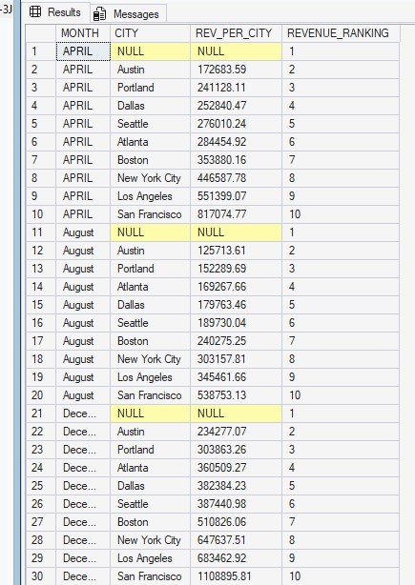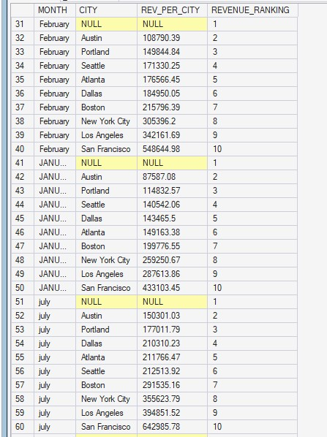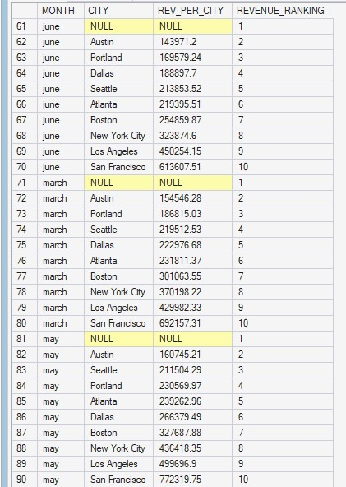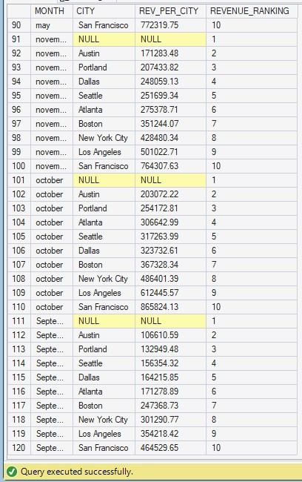
From the city breakdown:

Top Performing Cities (Consistently High Revenue)

- San Francisco (highest contributor across most months)
- Los Angeles
- New York City

Moderate Performing Cities

- Atlanta
- Seattle
- Boston

Lower Performing Cities

- Austin
- Portland
- Dallas

Evaluation of the Assistant Manager’s Suggestion

Suggested cities:
- Los Angeles (top performer)
- New York (top performer)
- Atlanta (moderate, not top tier)
- San Francisco (top performer)
- Seattle (moderate)

Conclusion

The suggestion is partially correct:
- San Francisco, Los Angeles, and New York are strong revenue drivers → focus here
- Atlanta and Seattle contribute moderately → require selective investment, not priority focus

6. Recommendations

1. Address Mid-Year Sales Decline
- Introduce promotions between May and September.
- Launch targeted marketing campaigns during slow months
- Improve customer retention strategies

2. Leverage High-Performing Cities
Increase marketing in:
- San Francisco
- Los Angeles
- New York City
- These cities show consistent and high revenue potential.

3. Optimise Moderate Markets
- Use data-driven campaigns in Atlanta and Seattle
- Test growth strategies before scaling investment

4. Maximise Q4 Performance
- Prepare early for the October–December demand surge
Ensure:
- Adequate inventory
- Strong promotions
- Logistics readiness

7. Conclusion

The 2019 sales analysis reveals clear seasonal and regional patterns.
- The company experienced a mid-year decline (May–September), not April as initially claimed.
- Sales performance is strongly driven by trends in order volume.
- Q4 emerged as the most profitable period, with December being the peak month.
- At the city level, San Francisco, Los Angeles, and New York are the primary revenue drivers.
Overall, the business demonstrates strong growth potential, and with improved mid-year strategies and focused city-level marketing, revenue can be further optimised.

